Static Data
Static data will be implemented by coding.

Meta Tags:
Meta tags are snippets of text that describe a page’s content; the meta tags don’t appear on the page itself, but only in the page’s code. We all know tags from blog culture, and meta tags are more or less the same thing, little content descriptors that help tell search engines what a web page is about.
The three types of Meta Tags:
- Meta Keywords Attribute - A series of keywords you deem relevant to the page in question.
- Title Tag - This is the text you'll see at the top of your browser. Search engines view this text as the "title" of your page.
- Meta Description Attribute - A brief description of the page.
For each page (Homepage, Contact, Designers, Gallery, Highlights, About BFW, Schedule) we need Meta Keywords, Meta Title, Meta Description for both Arabic and English languages.

About BFW (both languages):
- Text about Beirut Fashion Week History (between 50 and 150 words).
- Text about Beirut Fashion Week Mission (between 50 and 150 words).
Contact US (both languages):
- Where we can find you?
- Country
- Address
- Phone/Mobile number
- Email
- Members and their Emails

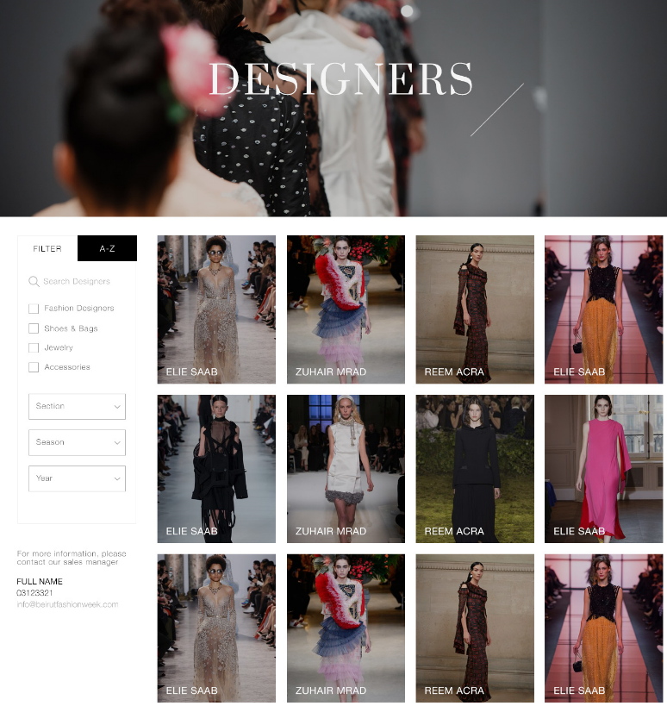
Designers & Gallery (both languages):
- Sales Manager:
- Name
- Email
- Phone/Mobile Number

Terms and Conditions (both languages):
- Text for Terms and Conditions.

Dynamic Data

About BFW:
Regarding the about page of the website, there is three main dynamic sections: charity, honorary members and testimonials. These sections should be filled from the backend of the website.
- For the charity section, access Cufex Menu About Charity
- Fill the title, picture (thumbnail will automatically upload according to the uploaded picture), and description.
- Link is optional.
- Priority field is used to order between records. (by default 10)
EX: record with priority 1 is shown before the other of priority 2.

- For the honorary members section, access Cufex Menu About Honorary Members
- Fill the name, position, company, country, email, and thumbnail
- Link is optional.
- Priority field is used to order between records. (by default 10)

- For the Testimonials section, access Cufex Menu About Testimonials
- Fill the full name, position, and description.
- Link is optional.
- Priority field is used to order between records. (by default 10)

Banners:
Go to Cufex Menu Banner Definition
- Fill the client name, position, client mobile, amount, picture, publishing and expiry dates
- Link is optional.
PS: For the banner position (location on the website), there is now two positions: homepage bottom and schedule bottom. In case you want to add new positions kindly contact us.

Bloggers:
Go to Cufex Menu Bloggers and fill the name and the priority of each blog.

Seasons:
Cufex Menu Season
- Fill the name, from date and to date
- Priority field is used to order between records. (by default 10)

Section:
Go to Cufex Menu Section
- Fill the section name
- Priority field is used to order between records. (by default 10)

Showrooms:
Go to Cufex Menu Showroom
- Fill the name and the related season.
- Priority field is used to order between records. (by default 10)
PS: Season contains all the records defined the season section.

Downloads:
Cufex Menu Downloads
- Fill the title, link and related season
- Priority field is used to order between records. (by default 10)

Highlights:
Two steps are required:
- Navigate to Cufex Menu Highlights Categories and fill the name (required) and the SEO Meta tags (optional)
- Navigate to Cufex Menu Highlights Definition
- Fill the title, related category, related season, related blogger, picture (thumbnail will automatically upload according to the uploaded picture), description, publishing and expiry dates.
- Also, you can display the highlight on the homepage by checking the “Show on homepage” field and choosing the title and the homepage picture.
- Priority field is used to order between records. (by default 10)

Designer:
Two steps are required:
- Navigate to Cufex Menu Designer Categories and fill the name (required) and the SEO Meta tags (optional)
- Navigate to Cufex Menu Designer Definition
- Fill the title, city, email, address, mobile, picture (thumbnail will automatically upload according to the uploaded picture), designer picture, and description.
- You can also choose the related designer categories, seasons, sections and showrooms.
- Other optional fields: Facebook, Instagram, Twitter, Pinterest links
- Also, you can display the designer on the homepage by checking the “Show on homepage” field and choosing the title and the homepage picture.
- Priority field is used to order between records. (by default 10)

Schedule:
There are two steps also:
- Navigate to Cufex Menu Schedule Categories and fill the name and the priority of each schedule category and the SEO Meta tags (optional)
- Access Cufex Menu Schedule Definition
- Fill the related designer, related schedule category, date and time.
- You can also display the schedule on the homepage by checking the “Show on homepage” field and choosing the title and two pictures that will appear next to each other on the homepage.
- Priority field is used to order between records. (by default 10)

Sponsors:
- Navigate to Cufex Menu Sponsors Categories and fill the name and the priority of each sponsor category and the SEO Meta tags (optional)
- Access Cufex Menu Sponsors Definition
- Fill the title, related category, and picture.
- Link is optional.
- Priority field is used to order between records. (by default 10)

Venues:
Go to Cufex Menu Venues and fill the title, related season, email, address and mobile.

